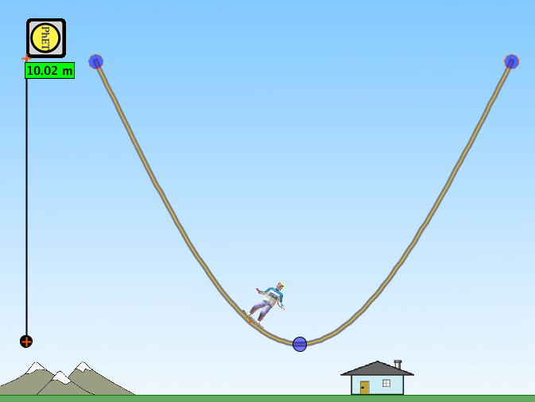
Energy Skate Park
Name:

Create a ramp like the one shown that is 10 metres tall. Make sure the ramp does not touch the ground.

Drop the skater from the top of the ramp so that he reaches the top of the ramp on the other side and comes back again.

Open the ‘Energy vs. Position’ graph and wait until a full set of data has been collected. Use this graph to fill in the information in the table below.

 | PhET Skater | Star Skater | Bulldog | Bug
Maximum potential energy
Minimum potential energy
Maximum kinetic energy

1. Which of the skaters had the most energy?

2. Why did this skater have the most energy?

3. Why does the total energy line remain flat?

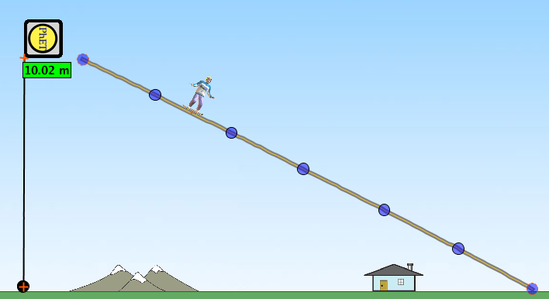
Set up your ramp so that it looks like the one shown.

Drop the skater from each of the dots on the ramp, starting from the top, and complete the table below.

Dot | 1 | 2 | 3 | 4 | 5 | 6
Max. potential energy
Max. kinetic energy
4. What was the effect on the skater’s maximum potential energy when he was placed further down the ramp?

5. Explain why this happened.

6. What was the effect on the skater’s maximum kinetic energy when he was placed further down the ramp?

7. Explain why this happened. (Note: it is not because of the height)
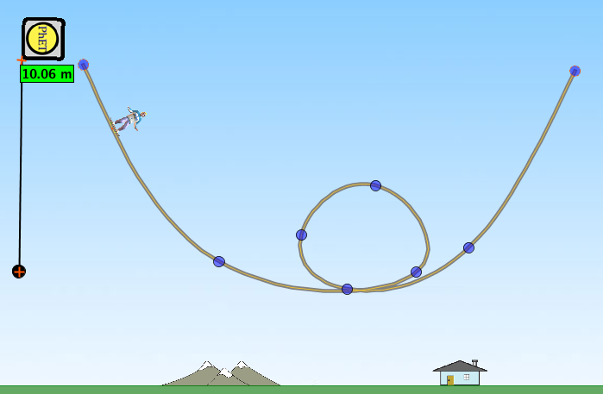

Set up your ramp so that it looks like the one shown.

In the table below record the maximum potential energy for each of the skaters at the top of the loop. Repeat this on the Moon, and on Jupiter. You will need to place the skater at the top of the ramp each time you change location.

 | PhET Skater | Star Skater | Bulldog | Bug
Earth
Moon
Jupiter

8. Explain why the maximum potential energy of the skaters was different at each location.

9. What are the values of gravity on Earth, on the Moon and on Jupiter?

10. a) Increase the friction on the track and explain what effect this has on the total energy of the skater.

b) What type of energy is the friction causing the other energy to transform into?

