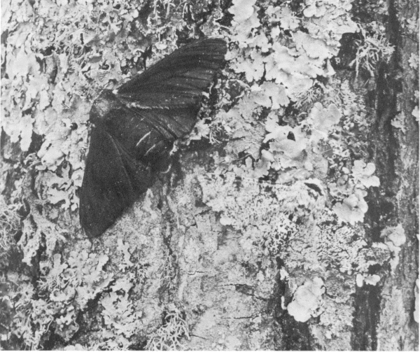
Natural Selection Activity: Peppered Moth Name:

Modern evolution theory states that if the frequency of genes in a population changes over time, then the population is evolving.

Peppered moths range in color from dark to light. The dark moths have the dominant gene for wing scale color and are either DD or Dd. The light-colored moths have the recessive genes and are dd.

INSTRUCTIONS
To see how peppered moths use camouflage to avoid bluejays…
Go to: http://www.biologycorner.com/worksheets/pepperedmoth.html
Click: Natural Selection Simulation
Answer: #1 below
Play for 2 minutes, you are the Blue Jay eating as many moths as possible.

Release moths in the lichen-covered forest.

1. Before the blue jay starts to eat, what percentage of moths are light-colored? **
what percentage of moths are dark-colored? **

2. Feed your bluejay for 2 minutes by clicking on as many moths as possible.
What percentage of the moth population is light-colored now? **
What percentage of the moth population is dark-colored now? **

3. In the lichen colored forest, what trait is selected for? **
What trait is selected against? **

NOW click on “post industrial”…DO NOT RESET
Release moths in the soot-covered forest.

4. Before the blue jay starts to eat, what percentage of moths are light-colored? **
what percentage of moths are dark-colored? **

5. Feed your bluejay for 2 minutes by clicking on as many moths as possible.
What percentage of the moth population is light-colored now? **
What percentage of the moth population is dark-colored now? **

6. In the soot covered forest, what trait is selected for? **
What trait is selected against? **

7. What kind of selection is changing the distribution of moth colors in the lichen and soot covered forests? Drag and drop the red circle to circle the correct answer.

directional disruptive stabilizing

