Wind-up Toy Physics
Name:______________
Follow your teacher’s directions to complete this lab activity.
Be sure to record your lab results in the charts!

Trial | Distance Traveled | Time
1
2
3

Materials and Equipment:
- One Wind-up Toy
- One stopwatch per team
- One meter stick per team
- String
- Expo marker

Speed = Distance / Time
- Calculate the speed for each trial using the total time and total distance. Show your work!
Trial 1:_______ Trial 2:_______ Trial 3:_______

- Construct a graph to show your results. (Distance vs. Time)
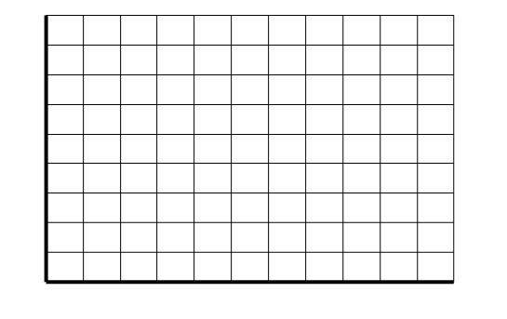

Trial 3
Trial 2
Trial 1

- Do your graphs represent a constant speed or an average speed?

- Are your results reliable? Explain

- What would you change about the lab?

