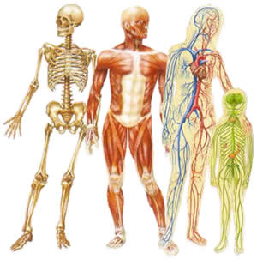
1st 6 Weeks Extra Credit Project / Due Sept. 29th, 2011
Human Body Systems Project
Your assignment is to research one of the major human body systems and create poster or an advertisement that describes that system. Your poster/advertisement should convince the other students in your class of the importance of that body system. You want to “sell” that system. You should describe the function of each major organ/component of your system. You should explain why that body system is essential for supporting life. You should also discuss any problems or diseases that can occur in your system if you don’t take care of your body properly.
Body systems to choose from:
1. Nervous 5. Endocrine 9. Skeletal
2. Circulatory 6. Excretory 10. Muscular
3. Digestive 7. Integumentary
4. Respiratory 8. Reproductive
Rubric | A | B | C | D | F
Correct parts are included  (20 points) | All major parts are included + some minor ones  20 | All major parts are included  17 | Most major parts are included, but missing several important ones  15 | Lacking several major organs/parts  13 | Incomplete  5
Function of system and organs  (20 points) | Excellent description of functions of system  20 | Correct description of functions of system  17 | Mainly correct description, but several mistakes or omissions  15 | Many mistakes and/or missing several key functions  13 | Incomplete  5
Diseases: What causes & how you prevent?  (15 points) | Excellent description of several diseases  15 | Correct diseases are described  13 | Only one disease is correctly described  11 | One disease is not thoroughly described  9 | None included  0
Persuasiveness  (15 points) | Highly convincing!  15 | Convincing  13 | Somewhat convincing  11 | Not very convincing!  9 | Who cares!  5
Creativity,  humor &  originality  (10 points) | Highly entertaining and original.  10 | Original and contains elements of humor  8 | Somewhat engaging, but lacks originality or creativity  7 | A bit dull, not very creative!  6 | Boring…  4
Group cooperation  (10 points) | Excellent!  10 | Good!  8 | Fair  7 | Poor  6 | None  4
Turn in on Time  (10 points) | Feb.17  10 | 1 day late  8 | 2 days late  7 | 3 days late  6 | 4 or more days late = 5

