Name:________________________
Period: _______
4th 6 Weeks District Test Review
Write the definition and give an example for each of the vocabulary words below.
- Producer
Definition:_________________________________________________________________________________________________________________
Example:______________________________________________________

- Consumer
Definition:_________________________________________________________________________________________________________________
Example:______________________________________________________

- Decomposer:
Definition:_________________________________________________________________________________________________________________
Example:______________________________________________________

- Herbivore
Definition:_________________________________________________________________________________________________________________
Example:______________________________________________________

- Carnivore
Definition:_________________________________________________________________________________________________________________
Example:______________________________________________________

- Omnivore
Definition:_________________________________________________________________________________________________________________
Example:______________________________________________________

- What is a food chain? Draw a picture of a food chain.

- What is a food web? Draw a picture of a food web.

- What is an energy web? Draw a picture of an energy pyramid.

- What is the source of all energy on the earth?

Use the food chain below to answer questions 11-14.
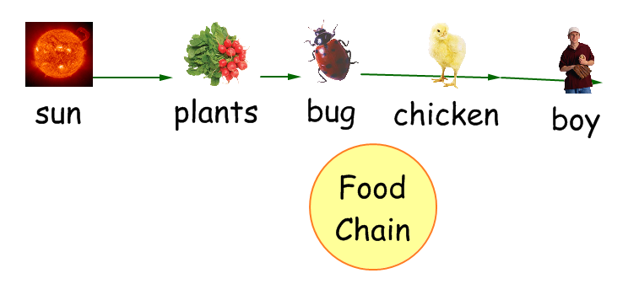

- The producer in this food chain is __________________.

- The primary consumer in this food chain is _________________.

- The secondary consumer in this food chain is __________________.

- The tertiary consumer in this food chain is _________________.
- What do the arrows on a food web or food chain represent?

- What is a trophic level?

- What is the rule of 10 in an energy pyramid?

- What is an autotroph? Give an example of an autotroph.

- What is a heterotroph? Give an example of a heterotroph.

- Put these organisms in the correct order they would go on an energy pyramid.

Hawk Snake Plant Rabbit

____________ _____________ _____________ _____________

- Complete the equation for photosynthesis below.

___________ + ____________ + sunlight ____________ +___________

- Label the reactants and the products in the equation above.
- Where in the plant cell does photosynthesis take place?

- What is chlorophyll?

- Fill in the blanks of the water cycle diagram below.
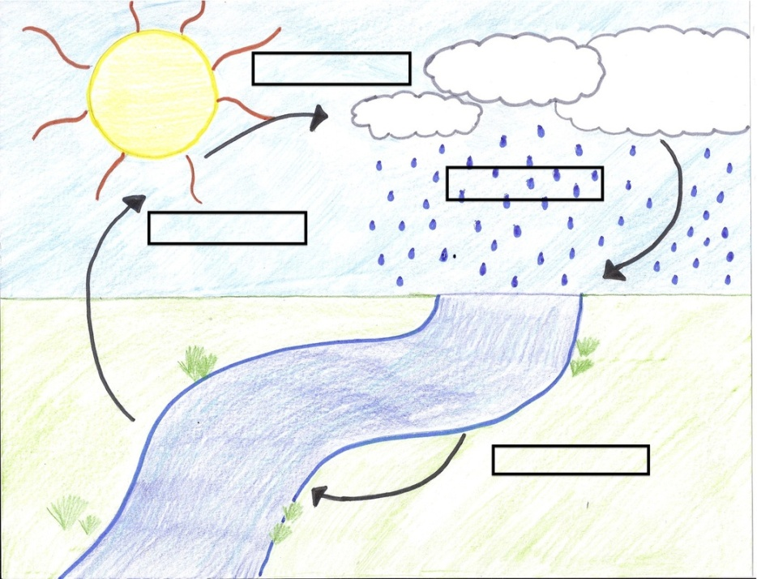

- Fill in the blanks of the carbon cycle diagram below.

- Fill in the blanks of the nitrogen cycle diagram below.
