2nd 6 Weeks District Test Review Study Sheet
Name: _____________________________ Period: _____
Directions: complete the questions below as you play flashcard race with your table partner.

1.What is the equation used to solve for speed?

2. What is the equation used to solve for distance?

3. What is the equation used to solve for time?

4. What is an indicator that a gas is produced during a chemical reaction?

5. What is the equation used to find average speed?

6. If there is a change in temperature due to 2 substances being combined, a ____________ has taken place.

7. What does City Girls Love Their Phones On stand for?
City=
Girls=
Lover=
Their=
Phones=
On=

8. Which ramp will require less force to move an object up it?

9. Which ramp will require more force to move an object up it?

10.To decrease the amount of force used, you’re inclined plane needs to be _________.

11. To increase the amount of force used, you’re inclined plane needs to be _________.

12. If 1 liquid is dissolved into another liquid, is this a sign of a chemical reaction?

13. Find the Net Force

14. Find the Net Force

15. Which way will the rope move?

16. Which way will the rope move?

17. If the two forces are pulling in the same direction what do you do to find the net force?

18. If the two forces are pulling in opposite directions what do you do to find the net for
19. Students conduct a laboratory investigation by rolling a toy car across a 2-meter table top. The student conducts 3 trials and records the data in the table. What is the average speed of the toy car?
Trial | Distance (m) | Time (s)
1 | 2 | 9
2 | 2 | 13
3 | 2 | 11

20. A rabbit ran 20 km between 2 fields. He started his run at 1:00 and finished at 3:00. What was the average speed the rabbit ran at?

21. The race horse track was 10 km long and it took the winning horse ¼ of an hour to complete it. How fast was the horse going?

22.Based on the chart below, what is the average speed of the runner?
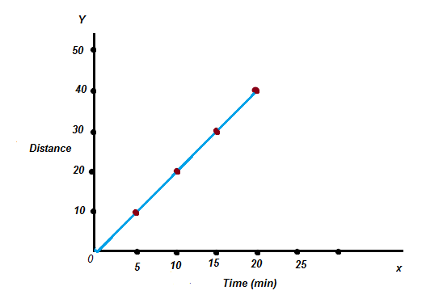

23. What was the average speed of the car during the first 12 seconds of it’s trip?
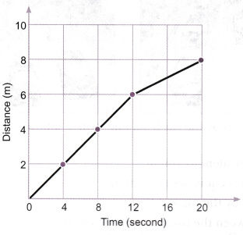

24. As a result of the change in forces from time A to time B, the car will…

Time A Time B

25. How would I enter .09 on a gridable as seen below?
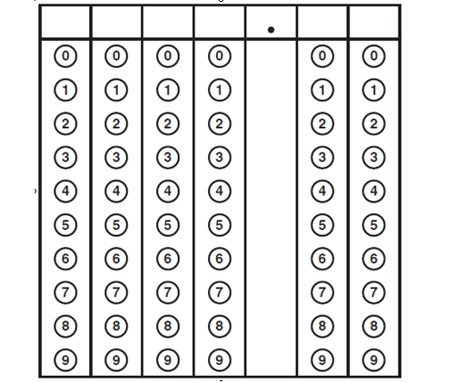

26. How would I enter .11 on a griddable as seen below?

27. What is happening from point A to point B?
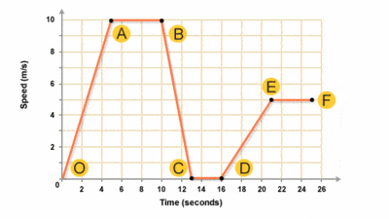
28. Which of the following NOT a correct unit for speed?
Miles km/min cm/s

29. What is the speed of this object at 3 seconds?
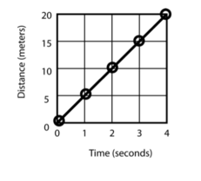
30. What is the average speed of this object?
