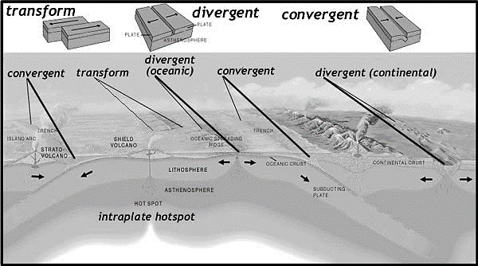
Tectonic Plate Movement Clay Demo
Objective: We will simulate how the tectonic plates move by using Play-doh in a hands on activity.
Materials:
Play-doh (2 colors per group)
Popsicle stick (5 per group)
Lab report (pre-printed, 1 per student)
Pen or Pencil
Paper Towel and Hand Sanitizer (clean hands afterwards)
Newspaper to cover desk top

Procedure:
- Read all directions first / Listen as Teacher explains activity
- Put your name and date at top of lab report
- Collect materials from teacher
- Follow directions on the lab report to complete the lab.
- At the end of the lab, use paper towel and cleaner for hands and top of desks as needed.

Name: ____________________________________ Class Period: ____________

Tectonic Plate Movement Clay Demo / Lab
Question: What are three different ways that the tectonic plates move and what landforms are created when this happens?
Collect research…
Record the definition for the terms listed below…
Key Term | Definition
Tectonic Plate
Convergent Boundary
Divergent Boundary
Transform Boundary
Trench
Folded Mountain

Form a Hypothesis (educated guess to answer the question above)

Procedure for _________________ Boundary:
Step 1: collect 2 colors of Play-doh from teacher
Step 2: Roll each color into a separate roll (like a snake shape), 1 roll per color
Step 3: Put the Popsicle stick on top of the play-doh so that only half of the play-doh roll is covered (see teacher for example) push the stick into play-doh so that you can wrap play-doh around stick to hold it in place / Do this for both colors
Step | Answer | Drawing
Step 4: Predict what will happen when you push the two colors towards each other (popsicle stick end in your hand)
Step 5: push the two sticks together and record what happens below (write and draw)

What type of boundary did you did you create? What type of landform does this create?
What does the play-doh represent in regards to plate tectonics?

Procedure for _________________ Boundary:
Step 1: collect 2 colors of play-doh from teacher
Step 2: Roll each color into a separate roll (like a snake shape), 1 roll per color
Step 3: Put the Popsicle stick on top of 1 color of play-doh so that only half of the play-doh roll is covered (see teacher for example) push the stick into play-doh so that you can wrap play-doh around stick to hold it in place
Step 4: Put 4 Popsicle sticks on top of 1 color of play-doh so that only half of the play-doh roll is covered (see teacher for example) push the stick into play-doh so that you can wrap play-doh around stick to hold it in place
Step | Answer | Drawing
5: Predict what will happen when you push the two colors towards each other (popsicle stick end in your hand)
6: push the two sticks together and record what happens below (write and draw)

What type of boundary did you did you create? What type of landform does this create?
What does the play-doh represent in regards to plate tectonics?

Procedure for _________________ Boundary:
Step 1: collect 2 colors of play-doh from teacher
Step 2: Roll each color into a separate roll (like a snake shape), 1 roll per color
Step 3: Put the Popsicle stick on top of the play-doh so that only half of the play-doh roll is covered (see teacher for example) push the stick into play-doh so that you can wrap play-doh around stick to hold it in place / Do this for both colors
Step | Answer | Drawing
Step 4: Predict what will happen when you slide the two colors past each other (popsicle stick end in your hand) one goes forward/north and other goes backwards/south
Step 5: slide the two sticks past each other so that the sides touch and record what happens below (write and draw)
What type of boundary did you did you create? What type of landform does this create?

Procedure for _______________ Boundary
Step 1: collect 1 color of play-doh from teacher
Step 2: Roll the color into a long cylinder (like a snake shape)
Step | Answer | Drawing
3: Predict what you think will happen when to pull on both ends of the play-doh roll at the same time.
4: Put 1 hand on each end of the play-doh roll and pull till it is 2 sections.
What type of boundary did you did you create? What type of landform does this create?
What does the play-doh represent in regards to plate tectonics?

Conclusion, Was your hypothesis correct? Why or why not?

